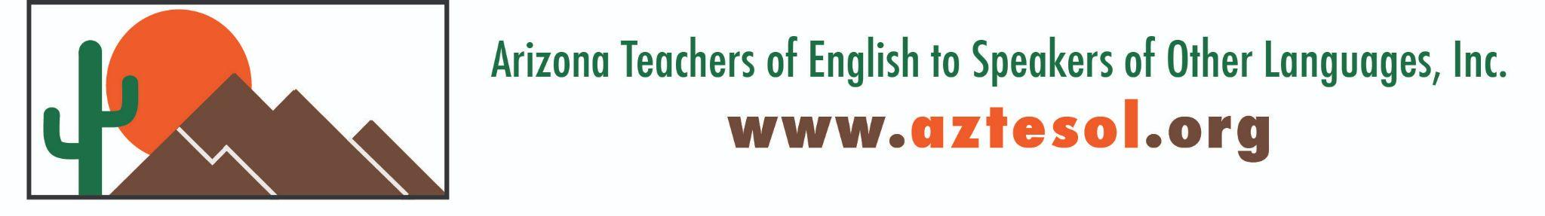

AZTESOL Board Meeting Summary
Date: October 18, 2025 | Time: 9:00–11:00 AM | Location: Virtual
The AZTESOL Board gathered to discuss leadership transitions, website updates, financial planning, and upcoming professional development initiatives.

Key Highlights
- Leadership & Governance:
The board reviewed open leadership positions—including Vice President, Secretary, Advocacy Chair, and Regional Representatives—and agreed to reinstate the Webmaster position.
- Website & GoDaddy Update:
Following a BBB complaint, GoDaddy offered a refund or two years of free hosting. A final decision on whether to continue with GoDaddy or move to a new platform will be made after a site review.
- Financial Update:
Treasurer Nicole Teyechea-D’Alessio reported $39,570 in total accounts, with a clear distinction between operating funds and Arizona Community Foundation grant funds. Conference funding is on track, with the goal of vendor and in-kind support.
- Board Recruitment:
Two new board candidates were introduced, and recruitment continues for key roles. All board members were reminded to review and sign the Board Member Contract.
- Communications & Outreach:
The team is streamlining communication protocols and increasing outreach through social media. Open positions will be promoted, and the next newsletter will be released in November.
- Professional Development:
A robust calendar of eight professional development webinars is planned for 2025–2026.

Featured Series: AI Literacy Training for Teachers
Presented by Nesma Nasr, this four-part AI Literacy professional development series will help teachers explore responsible and effective use of AI in education.
🧠 Teachers in the Loop: Empowering Teacher AI Literacy for Ethical, Responsible, and Effective AI Use
- Session Dates: October 29, November 5, November 12, November 19, 2025
- Time: 3:30–5:00 PM MST (Virtual)
- Presenter: Nesma Nasr, Northern Arizona University
- Registration: Click here
- Advocacy:
TESOL Affiliate Leadership Workshop proposal submitted for March 2026.
- Scholarships, Grants & Awards (SGA)
The board reviewed proposed updates to the program, including a new timeline and outreach strategies. Gwen Groth from the Arizona Community Foundation will be invited to the January meeting for further discussion.

Next Steps
- Finalize website hosting decision.
- Launch board recruitment and communications campaign.
- Prepare for upcoming webinars and newsletter.
- Review Grants & Awards materials ahead of the January board meeting.

📅 Next Board Meeting: January 17, 2026
💻 Location: TBD
AZTESOL continues to grow as a statewide network of educators dedicated to advocacy, professional development, and leadership in English language education.

